­

Blueberries are a common perennial crop in the southeastern US. Blueberries require acidic soil, so the soil must be acidified to 4.5-5.5 pH (Gardner, 2021). This is commonly done with sulfur (Stafne et al., n.d.). Before planting, any hardpans are removed with a subsoiler, and weeds are removed by thorough tilling (Stafne et al., n.d.). Tilling pine bark into the soil at planting to increase organic matter content has been found to make the crop substantially more productive, although fresh wood chips are counterproductive since they trap nitrogen (Stafne et al., n.d.). After the soil mixture is complete, it is pulled into raised rows to protect the roots from overwatering (Stafne et al., n.d.). Blueberries are typically planted between December-February, and can take 2-3 years to produce (Cramer, 2021).

SOIL ORIGINS AND CLASSIFICATION

Gold Boundless Bar

Choose a crop and location. Using SoilWeb, obtain the information. Identify the prominent series and order. Describe the horizons and amount of organic matter in the soil profile in layman’s terms. Included a photo of the horizons. Using the description of the soil series, describe the parent materials of the soil in layman’s terms.

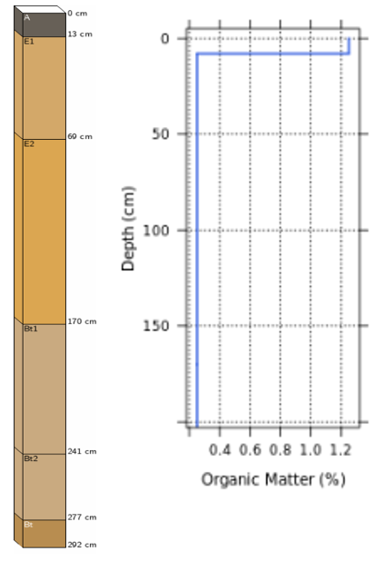

PHYSICAL PROPERTIES OF SOIL

Gold Boundless Bar

Described your soil texture and how it affects CEC, soil permeability, and drainage.

Hint: Find this information in the description of the soil series.

MICROORGANISMS IN YOUR SOIL

Gold Boundless Bar

Describe 3 effects of beneficial microorganisms in soil and at least two ways to increase the amount of microorganisms in your cropping system.

How to increase microorganisms:

* Way 1
* Way 2
* Way 3

EFFECT OF CLIMATE CHANGE

Describe the possible effect of climate change on the cropping system and the need for action in your own words.

IRRIGATION

Gold Boundless Bar

Described in detail how your cropping system is typically irrigated. If the plant can be irrigated with multiple ways, then describe that.

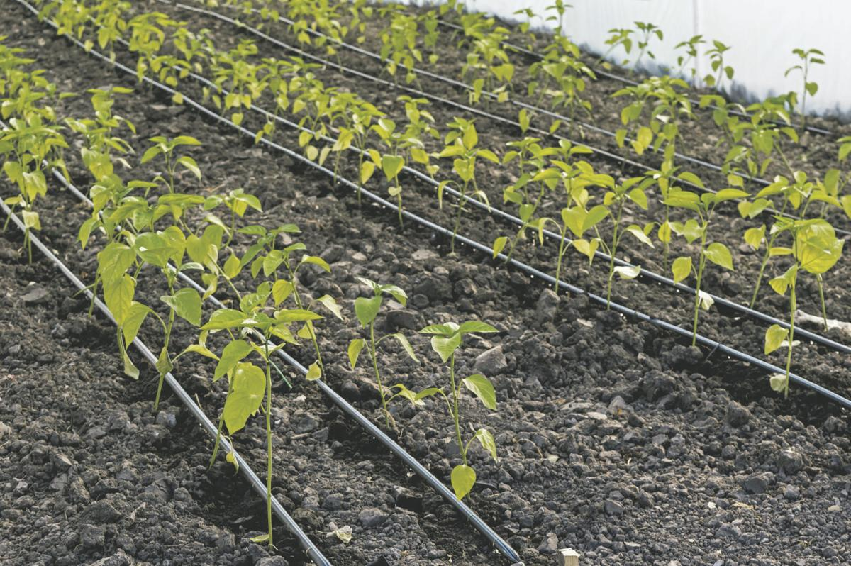

­

WATER NEED AND SCHEDULE

Gold Boundless Bar

Described crop water need based on the time of year/stage of growth. For example, just planted or seedling vs maturity or maintenance for stage of growth AND evapotranspiration rate for time of year. Thoroughly described a generalized watering schedule. This may be written out or put in a table. It should include differences in initial planting and maturity.

KNOWING WHEN TO WATER

Gold Boundless Bar

Thoroughly describe three ways to know when to water/monitor for soil moisture.

SOIL pH

Gold Boundless Bar

Described how to increase or decrease the pH depending on your soil pH and crop needs.

FERTILIZER RECOMMENDATIONS

Provide recommendations for fertilizing the plant including when, where, how much, and what type and the method(s) that are done (broadcasting, sidedressing, banding, etc.)

HOW TO DO A SOIL SAMPLE

Gold Boundless Bar

Described how to do a soil sample for your plant, including how deep to dig, number of samples, areas where the samples should be done, how to collect it, and how to send it.

NUTRIENT DEFICIENCIES

Gold Boundless Bar

Describe at least three nutrient deficiencies that occur on your plant, including a description of symptoms (showing photos of symptoms) and how to correct it.

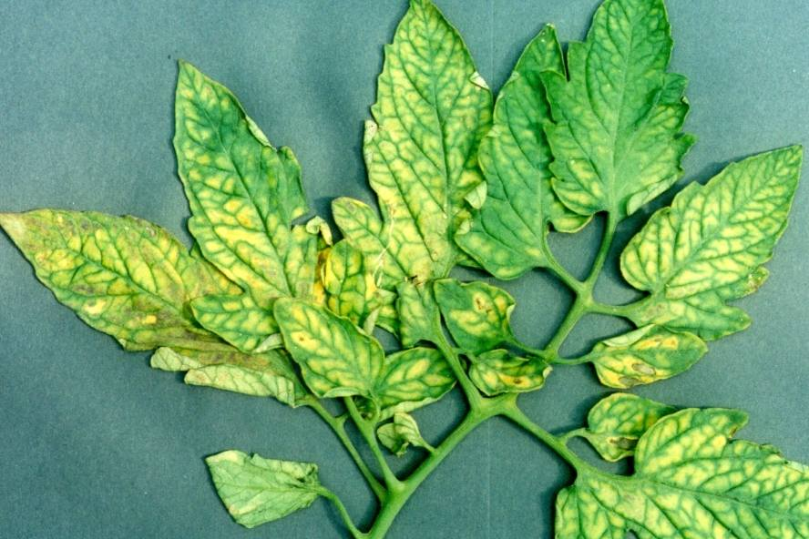

Magnesium deficiency of tomato

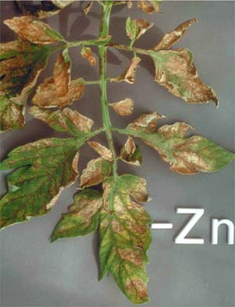

Zinc deficiency of tomato

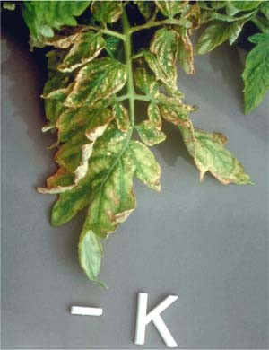

Potassium deficiency of tomato

REFERENCES

Gold Boundless Bar

Gardner, F. (2021, November 1). *Soil pH For Blueberries: What You Should Know*. Plantgardener. https://www.plantgardener.com/soil-ph-blueberries/

‌

Stafne, E., Melanson, R., Layton, B., Silva, J., & Canales, E. (n.d.). *Establishment and Maintenance of Blueberries | Mississippi State University Extension Service*. Extension.msstate.edu. Retrieved August 28, 2022, from https://extension.msstate.edu/publications/publications/establishment-and-maintenance-blueberries

‌

Cramer, E. (2021, July 6). *How To Grow Blueberries By The Bushel*. Epic Gardening. https://www.epicgardening.com/how-to-grow-blueberries/

‌